 

**INSTITUTE FOR ADVANCED COMPUTING AND SOFTWARE DEVELOPMENT AKURDI, PUNE**

Documentation On

**“AIRLINE TICKET RESERVATION SYSTEM”**

PG-DAC SEPT 2021

Submitted By:

**Group No: 15**

**Atul Kumar (210941220035)**

**Ankit Sachan (210941220025)**

**Mr. Prashant Karhale Mr. Chetan Pardeshi**

Centre CoordinatorProject Guide

**Table of Contents**

**1.Introduction ………………………………………………………... 4**

Problem Statement……………………………………………………………….4

Aim & Objectives………………………………………………………………….4

**2.Overall Description…………………………………………………5**

Proposed Methodology…………………………………………………………..5

Operating Environment ………………………………………………………….5

Design and Implementation Constraints ………………………………………5

**3.Requirements Specification………………………………………6**

External Interface Requirements……………………………………………….6

**4.System Diagram…………………………………………………….7**

Activity Diagram…………………………………………………………………..7

Data Flow Diagram ………………………………………………………………9

ER Diagram...……………………………………………………………………10

**5.Table Structure…………………………………………………… 11**

Booking…………………………………………………………………………..11

booking_seq ………………………...…………………………………………..11

flight……………………………………………………………………………....11

flight_seq ………………………………………………………………………..12

passenger……………………………………………………………………….12

passenger_seq………………………………………………………………….12

ticket ……………………………………………………………………………..12

ticket_seq………………………………………………………………………..13

user ……………………………………………………………………………...13

user_seq ………………………………………………………………………...13

**6.Implementation Screenshots ……..…………………………... 14**

**7.Conclusion………………………………………………………... 23**

Future Scope ……………………………………………………………………23

GitHub Link ……………………………………………………………………23

**8.References………………………………………………………… 24**

**List of Figures**

Figure 1 Admin Activity Diagram ……………………………...…. 7

Figure 2 User Activity Diagram………………………………….… 8

Figure 3 Data Flow Diagram…………………………………….… 9

Figure 4 Level 1 Data Flow Diagram for Admin……………….… 9

Figure 5 Level 2 Data Flow Diagram user………………………..10

Figure 6 ER Diagram …………………………………………….…10

1. **INTRODUCTION**

**Introduction**

Airline Reservation System is software which is helpful for ticketing manager as well as the customers. In the later system all the activities were done manually. It was very time consuming and costly. Our Airline Reservation System deals with the various activities related to the Flights.

There are mainly 3 modules in this software:

1. Search flights

2. Flight reservation

3. Add/Delete flights

In the Software only user with the legal username and password can sign in. A ticketing manager can book, Add or Delete any flight for any customer. Flights are booked through Flight Reservation Module in which all the details regarding customer and his flight are entered. A receipt no. is provide to every customer which is unique for each customer.

**Problem Statement**

There are many problems found in the todays portal system. The problems created in the existing system enforced us to develop the new system which minimize the problem of the existing system. In today’s system we have to store all data manually which consumes lots of time. Its application depends works on minimum peoples that is department level.

**Aims and Objective**

Our software will perform and fulfil all the tasks that any customer would desire. Our software system mainly deals with customers Searching and booking flight in the airlines. The various features added to the project provide all the functions to make the task easy to perform.

System analysis can be categorized into five parts:

1. System planning and initial investigation
2. Information Gathering
3. Applying analysis tools for structured analysis
4. Feasibility study
5. Cost/ Benefit analysis.

**2. Overall Description**

**Proposed methodology:**

In our proposed system we have the provision for adding the details of the customers by ticketing manager with the help of predefined format and drop-down lists. So the overhead of the ticketing manager is become less. Another advantage of the system is that it is very easy to edit the details of the customers and delete a ticket entry when it found unnecessary. Our proposed system has several advantages User friendly interface Fast access to database Less error More Storage Capacity Look and Feel Environment Quick transaction All the manual difficulties in managing the customer details in a airline reservation database have been rectified by implementing computerization.

**Operating Environment**

**Server Side:**

Processor: Intel® Xeon® processor 3500 series

HDD: Minimum 500GB Disk Space

RAM: Minimum 4GB

OS: Windows

Database: MySQL

**Client Side (minimum requirement):**

Processor: Intel Dual Core

HDD: Minimum 80GB Disk Space

RAM: Minimum 2GB

OS: Windows

**Design and Implementation Constraints:**

• The application will use Java spring boot, React and CSS as main web technologies.

• The frontend is designed in react and backend is designed using java .

• SMTP protocol is used for email communication.

• Several types of validations make this web application a secured one and SQL Injections can also be prevented.

• Since it is a java spring application, internet should not be required

**3. Requirement Specification**

**External Interface Requirements**

**User Interfaces**:

• All the users will see the same page when they enter in this website. This page asks the users a username and a password.

• After being authenticated by correct username and password, user will be redirect to their corresponding profile where they can do various activities.

• The user interface will be simple and consistence, using terminology commonly understood by intended users of the system. The system will have simple interface, consistence with standard interface, to eliminate need for user training of infrequent users.

**Hardware Interfaces**:

• No extra hardware interfaces are needed.

• The system will use the standard hardware and data communication resources.

**4. System Diagram**

**Admin:**

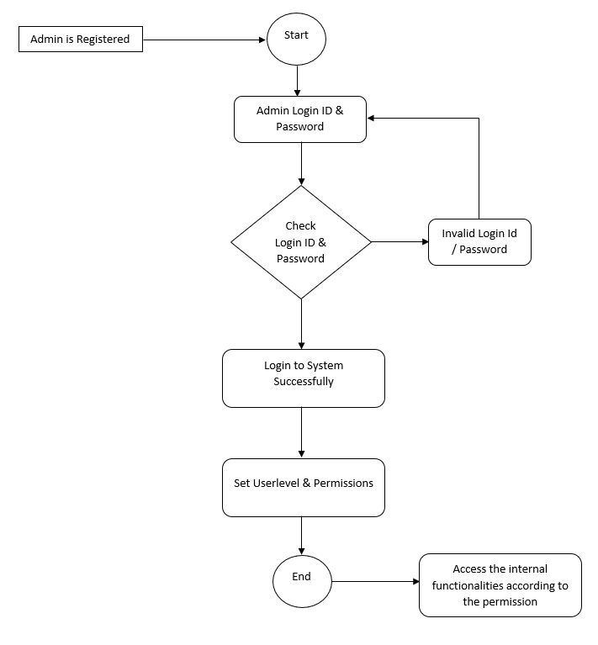

**Activity diagram for admin**

**User:**

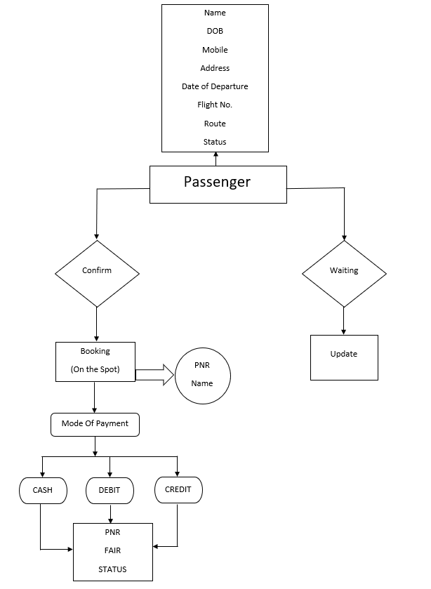

**Activity diagram for user**

**Data-flow :**

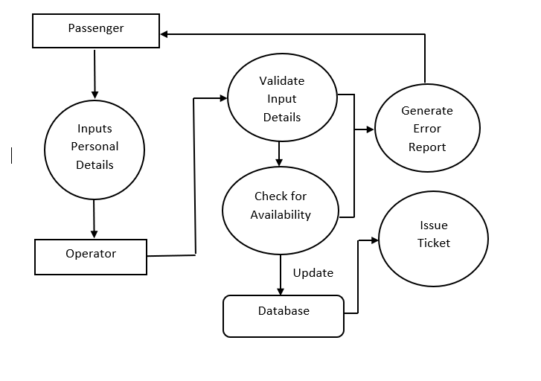

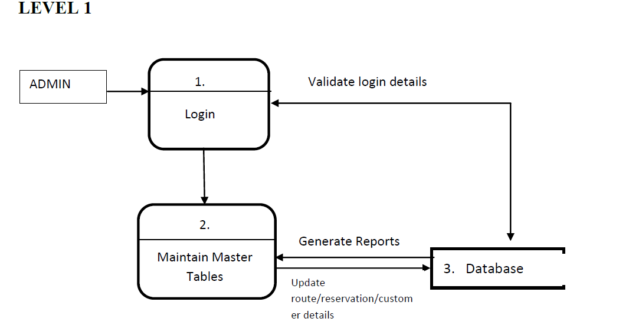

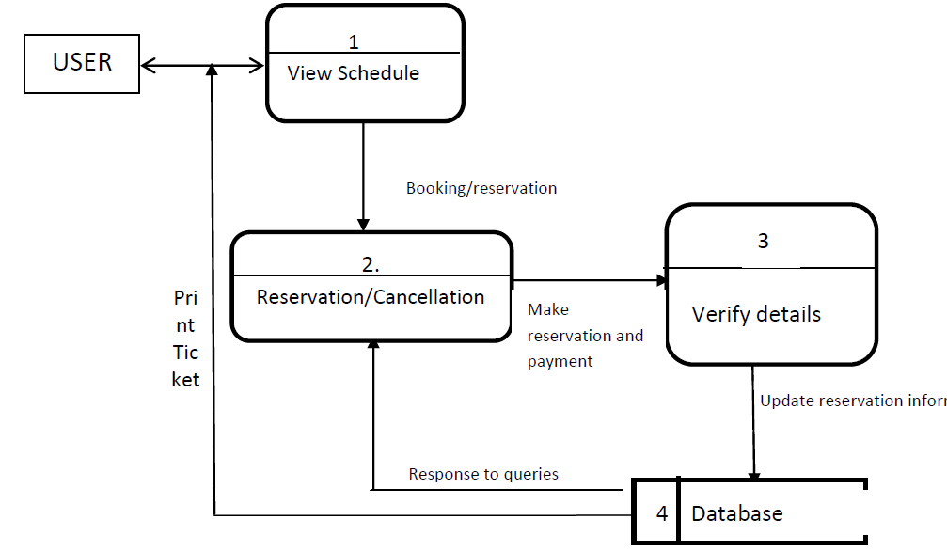

**Data flow diagrams**

**E-R Diagram:**

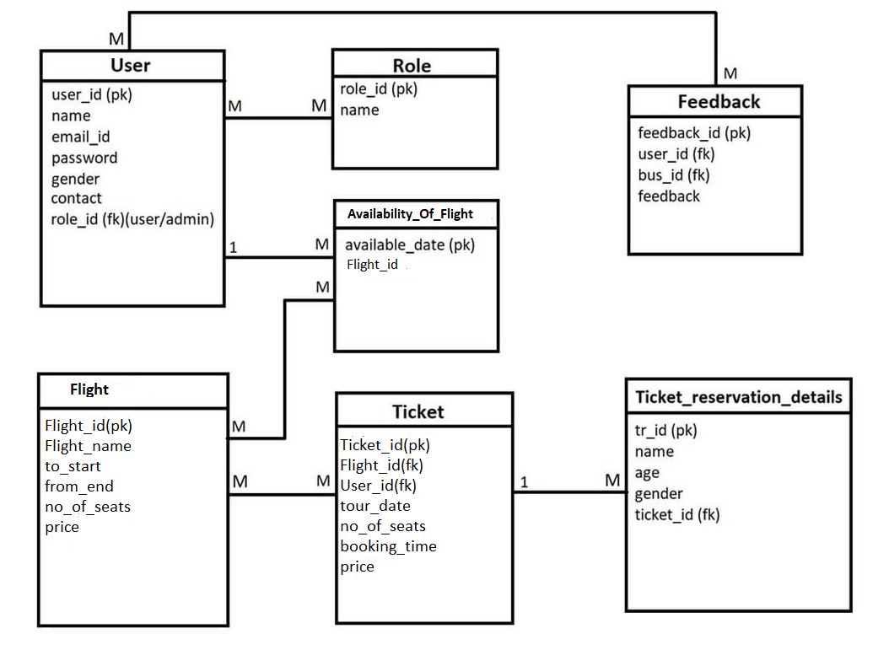

**E-R Diagram of ARS**

**5. Table structure**

**Booking table**

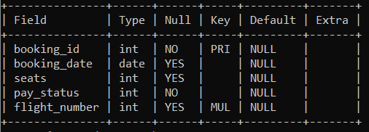

**Booking_seq table**

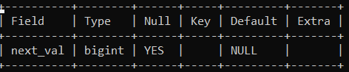

**Flight table**

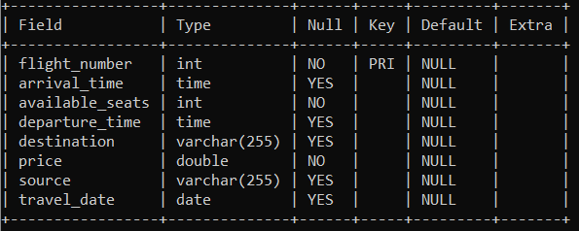

**Flight_seq table**



**Passenger table**

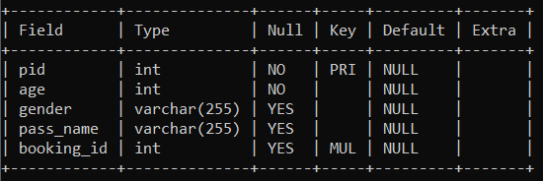

**Passenger_seq table**



**Ticket table**

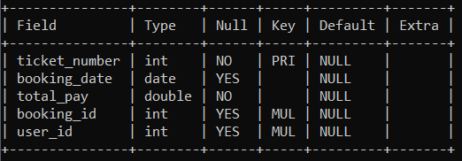

**Ticket_seq table**



**User table**

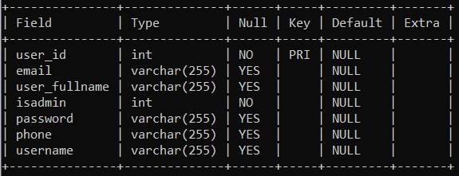

**User_seq table**



1. **Implementation Screenshots**

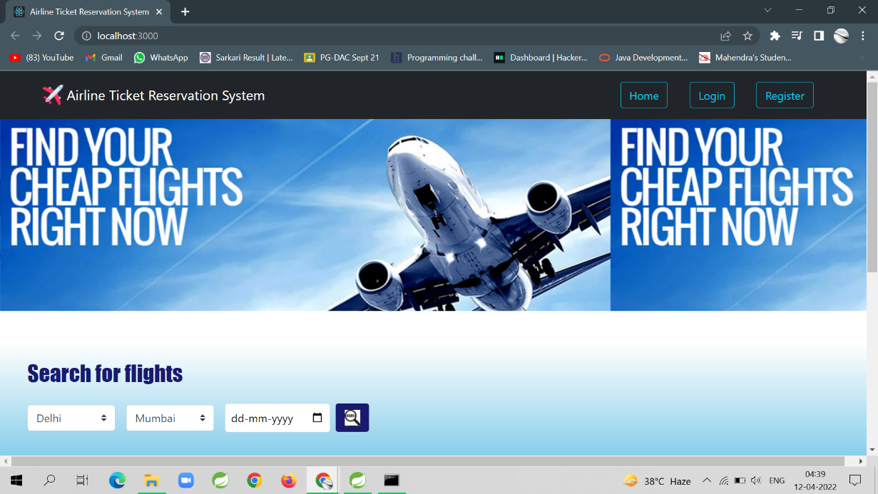

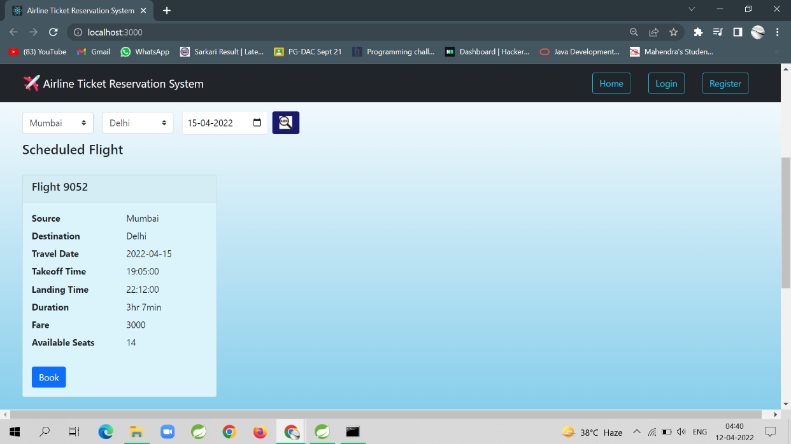

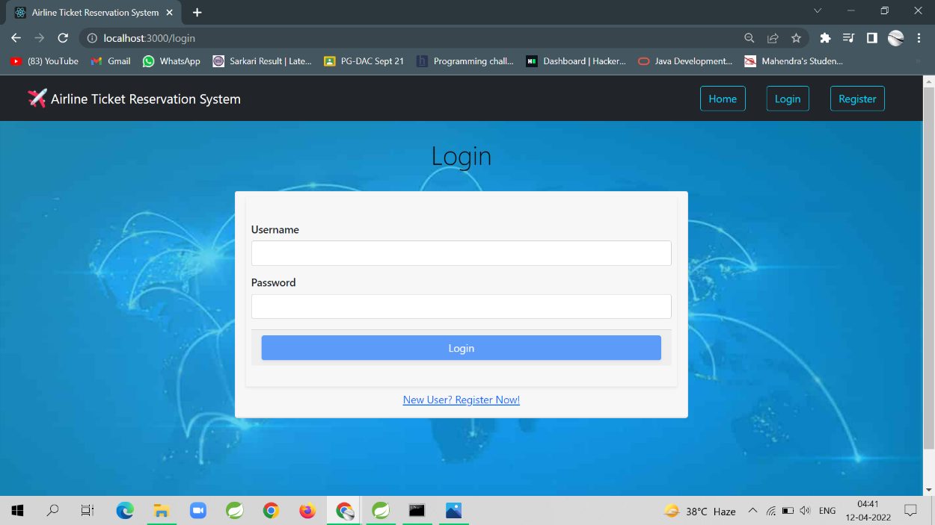

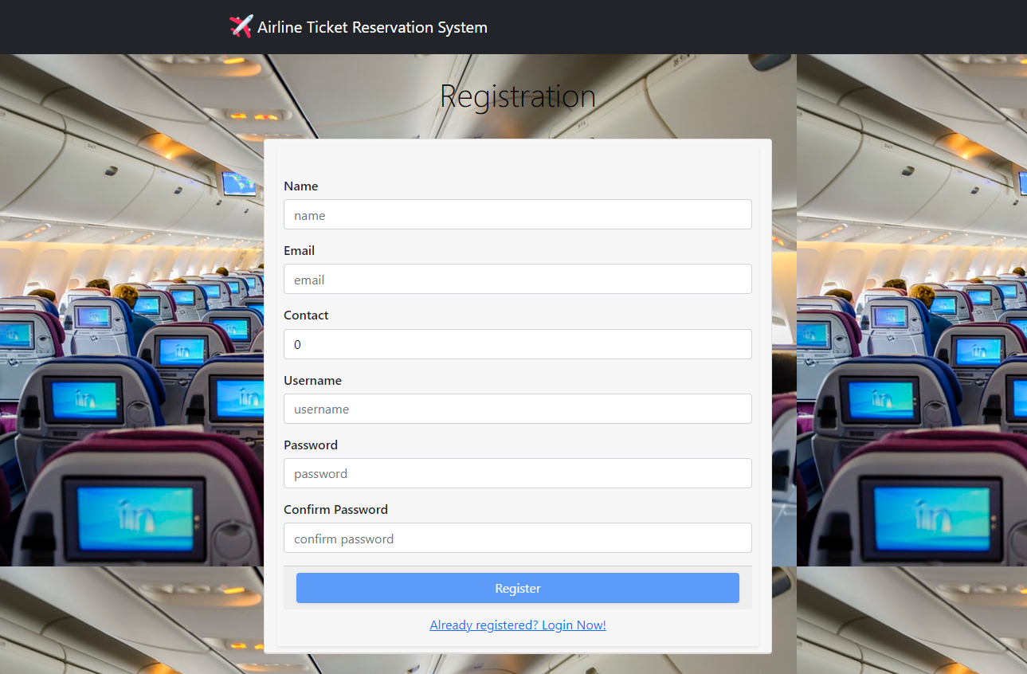

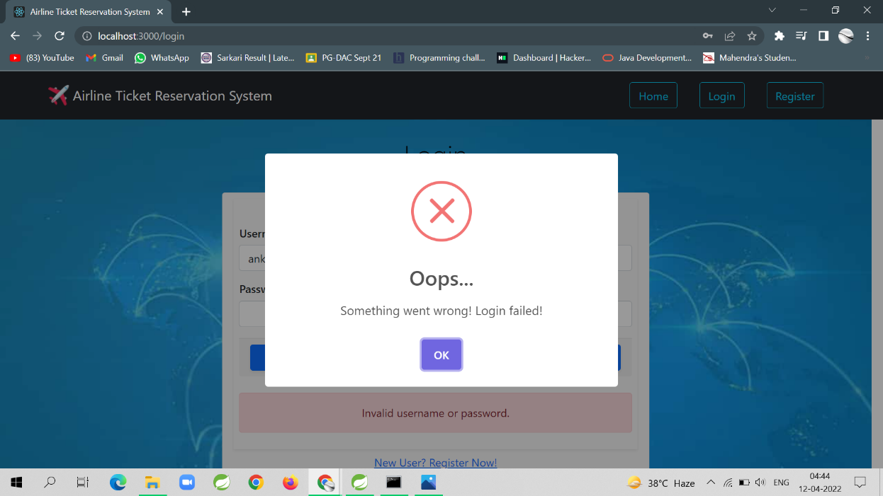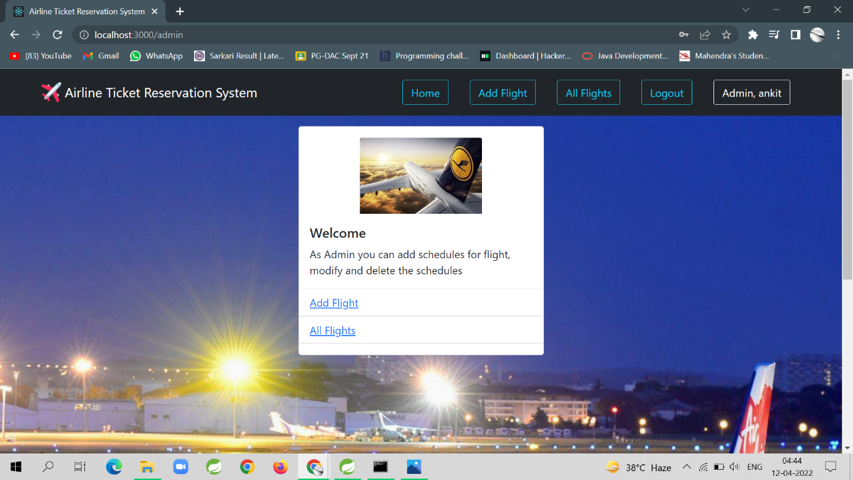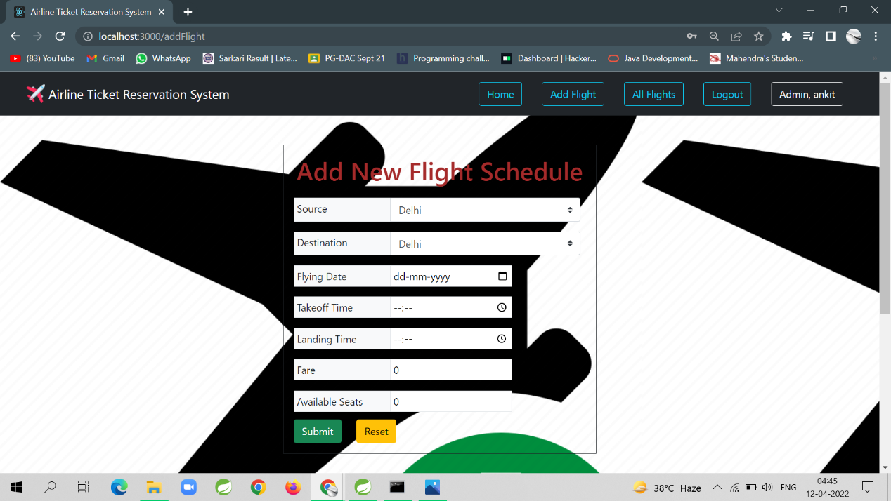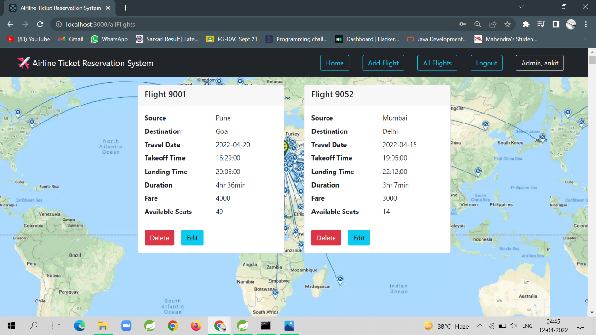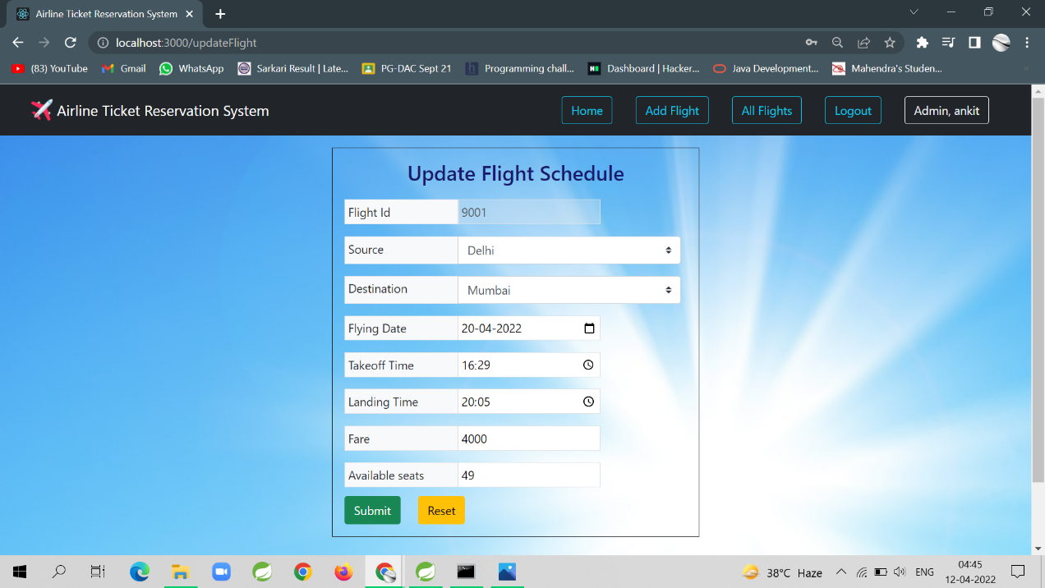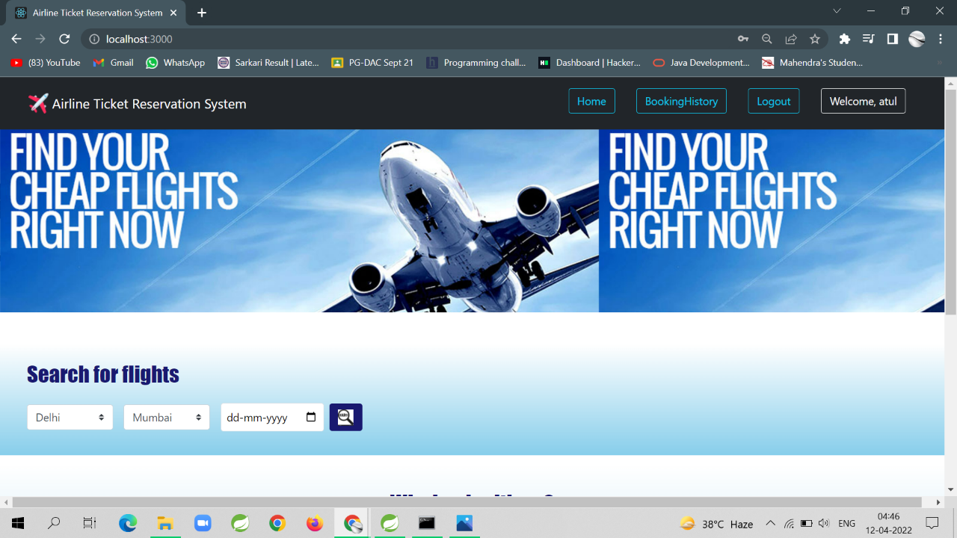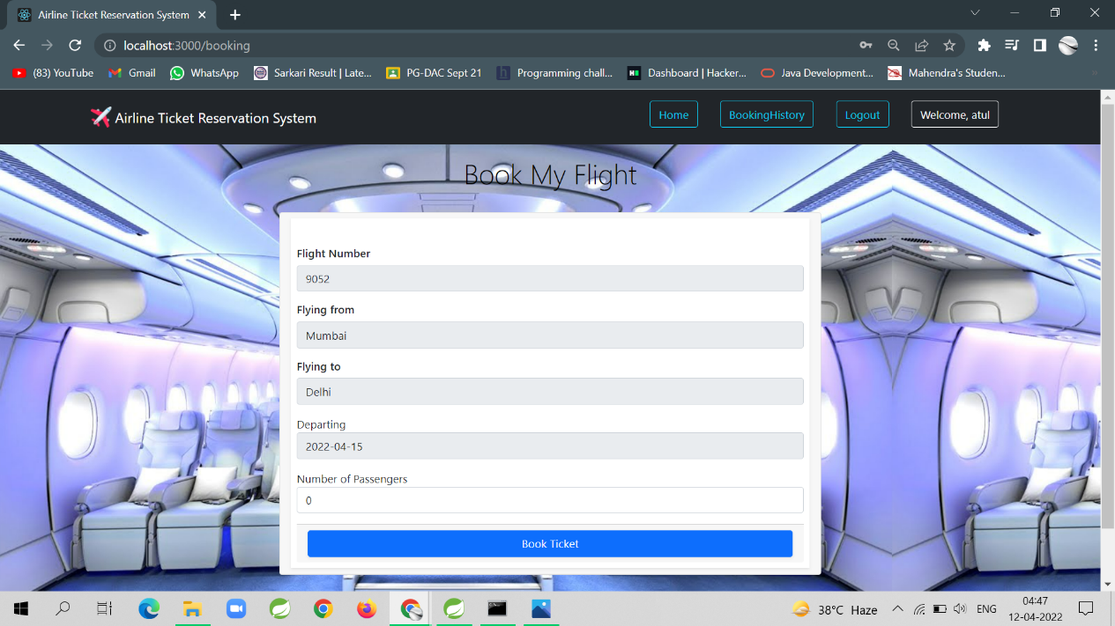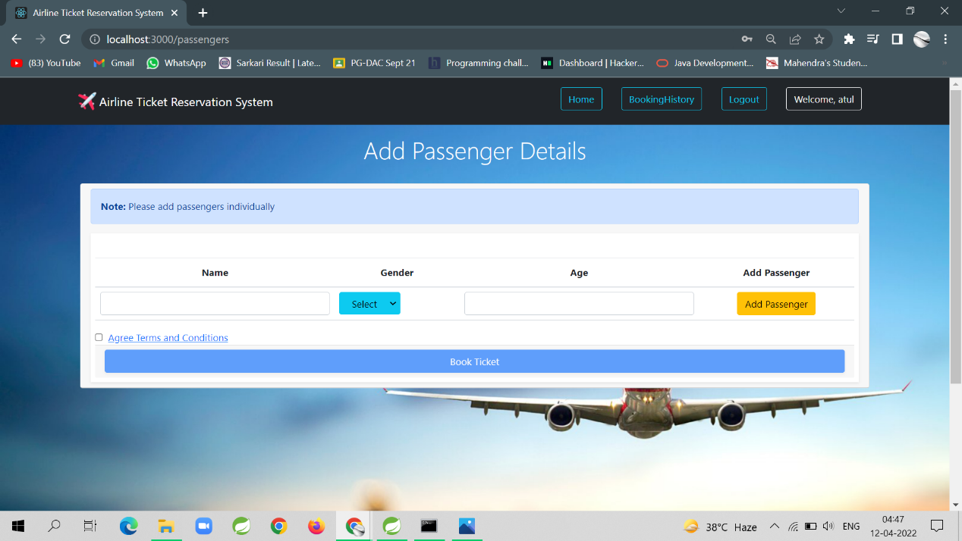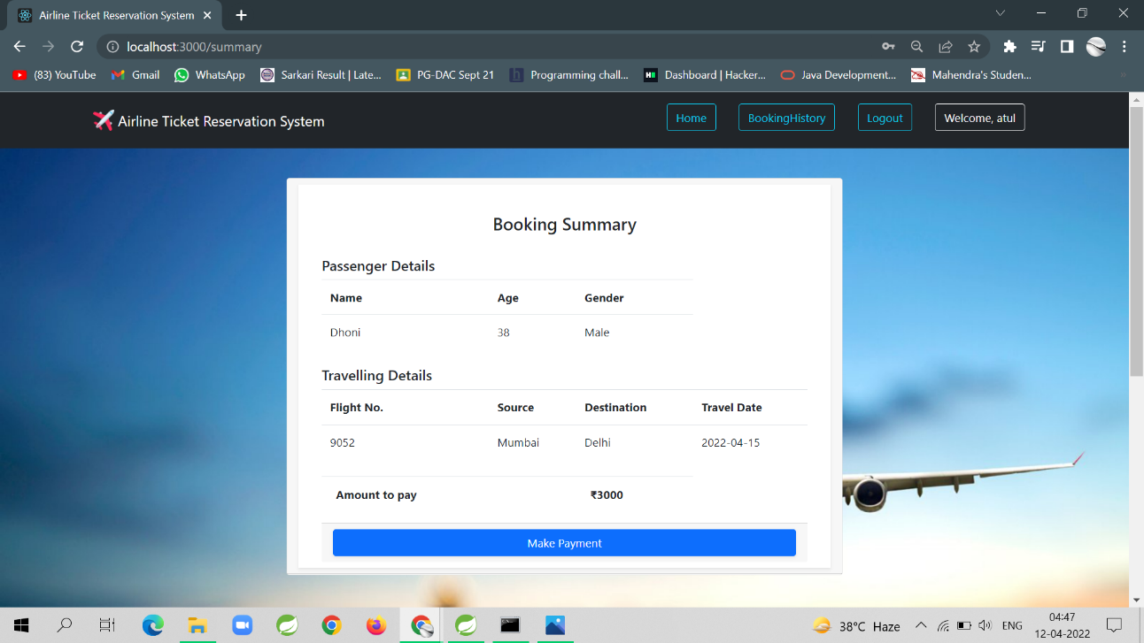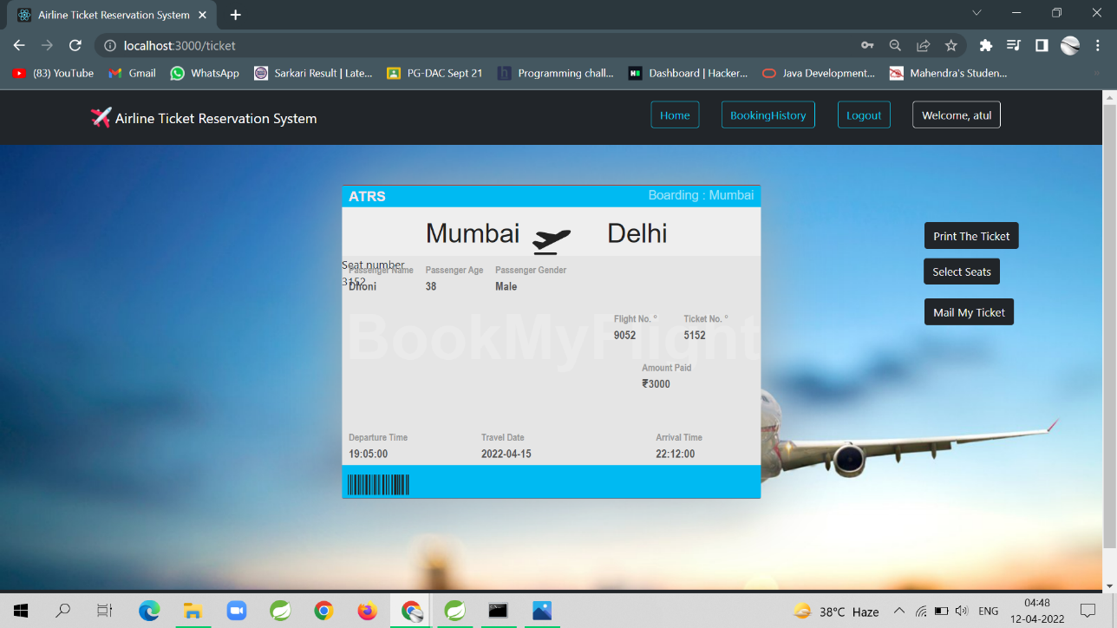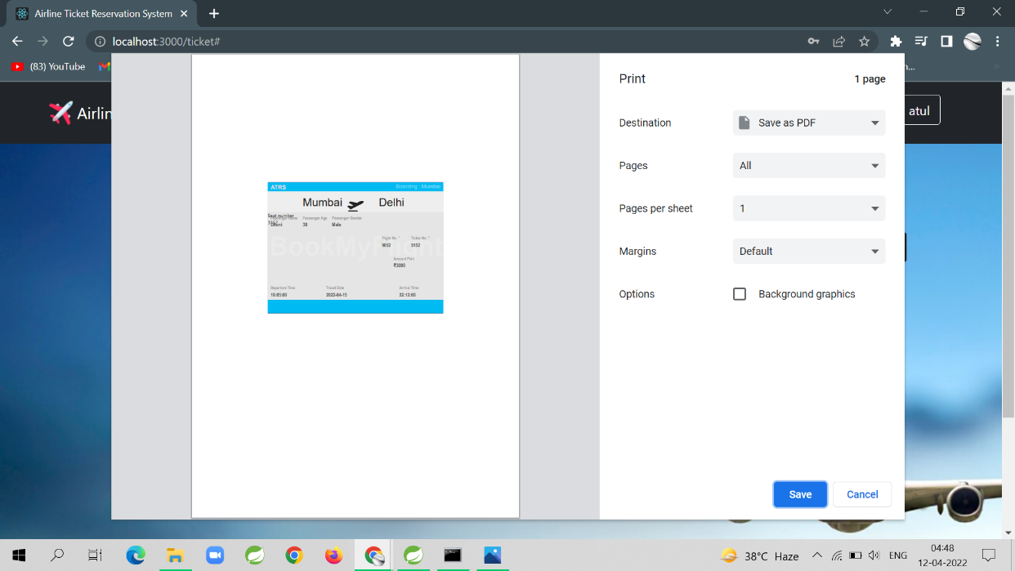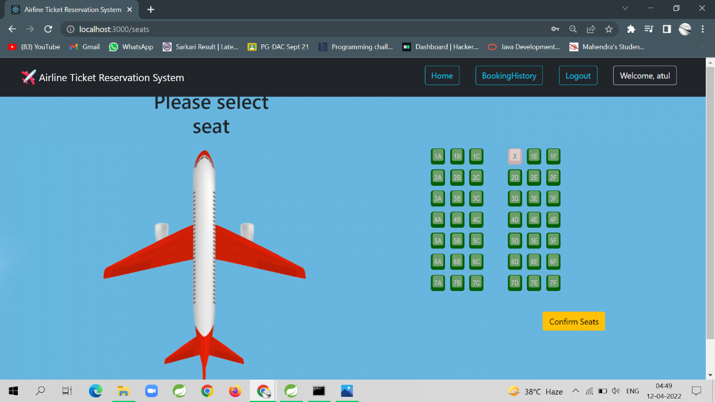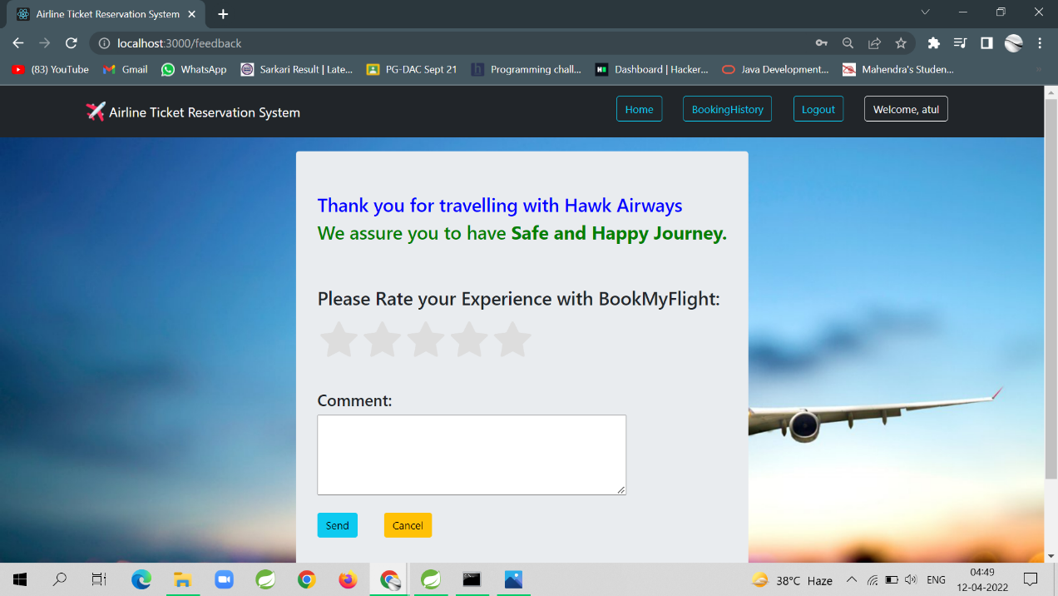

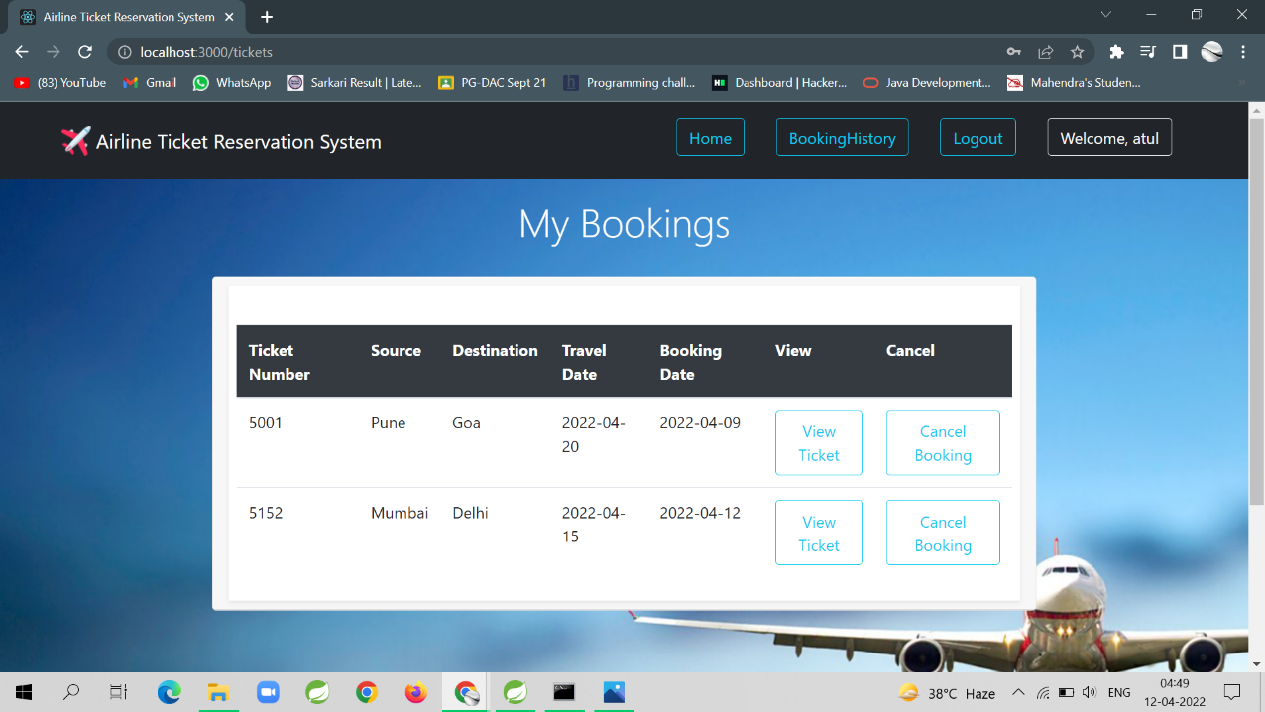

1. **Conclusion**

This project aid in automating the existing manual system. This is a paperless work. It can be monitored and guarded remotely. It cut down the man power required and provides accurate information. All years together huddled information can be saved and can be accessed at any time. For this reason, the data stored in the repository helps in taking decision by management. So, it is improved to have a Web Based system. Admin and user can get the required information without delay. This system is crucial in the travelling booking business.

**Future scope**

This project can be enhanced further by adding international flights, passenger list for the members to reduce the extra work of the admin. The software is flexible enough to be modified and implemented as per future requirements. We have tried our best to present this free and user–friendly application for ticket booking.

**9. References**

<http://www.ijcstjournal.org/volume-7/issue-1/IJCST-V7I1P4.pdf>

<https://bootstrapmade.com>

<https://www.javatpoint.com/java-mail-api-tutorial>

<https://angular.io/docs>

<https://javaee.github.io/javaee-spec/javadocs/>

https://www.w3schools.com